1. 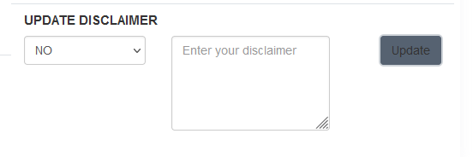

When update button clicked- not showing notification as updated successfully

1. UPDATE seller address when updated not showing notification as updated successfully

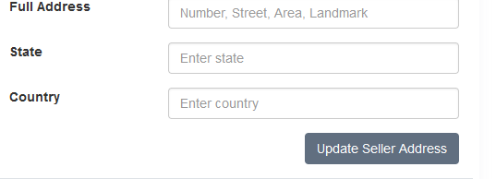

1. Add table numbers- 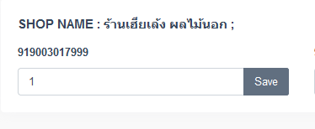

When save button is clicked- get notification that “not updated” and values getting updated

1. 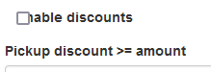

Alignment- Table

1. GST- ALIGNMENT

